1. What is the R programming language how it is work ?

* R Programming Language is an open-source language mostly used for machine learning, statistics, data visualization, etc.
* It is an interpreted language that supports both object-oriented and procedural programming.

1. Why did the R programming language com to be ?

* R is an open sourc implementation of the s language combined with lexical scoping semantics from schema , which allow objects to be defined in predetermined blocks rather than the entirety of the code.
* S was created by Rick Becker, John Chambers, Doug Dunn, Jean McRae, and Judy Schilling at Bell Labs around 1976.

1. Create a tiny application that prints the installed version of R.

* R is an**interpreted language**; users can access it through a command-line interpreter.
* If a user types 2+2 at the R command prompt and presses enter, the computer replies with 4.
* R supports procedural programming with functions and, for some functions, object-oriented programming with generic functions.

1. 4. Create a simple software that accepts user input (Name, Age, and Qualification)

and displays the results.

*

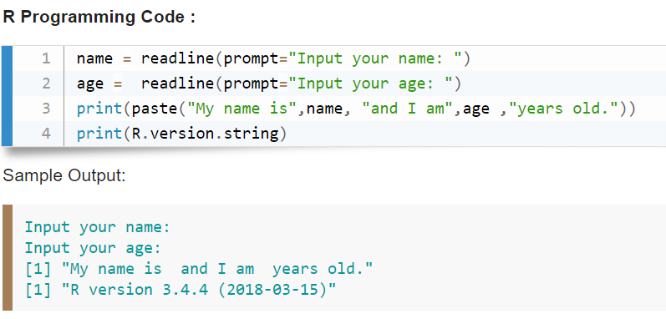

1. 5. What are some R programming applications?

* **Finance. Data Science is most widely used in the financial industry. R is the most popular tool for this role.
* **Banking. Just like financial institutions, banking industries make use of R f or credit risk modeling and other forms...
* ***Healthcare. Genetics, Bioinformatics, Drug Discovery, Epidemiology are some of the fields in healthcare that make...
* **Social Media. For many beginners in Data Science and R, social media is a data playground. Sentiment Analysis

1. 6. In which areas of healthcare does R play a significant role?

R is a language to do statistic. R is the first choice in the healthcare industry, followed by government and consulting.

The primary uses of R is and will always be,**statistic, visualization, and machine learning**.

The picture below shows which R package got the most questions in Stack Overflow.

1. What is R studio, and what does it do?

RStudio is**a powerful and easy way to interact with R programming**

considered as Integrated Development Environment (IDE) that provides a one-stop solution for all the statistical computing and graphics.

1. What is Mapping and How Does It Work?

There are many mapping environments that can be adopted in R. Three are presented in this tutorial: tmap, ggplot2 and plot_sf. Data used in the following exercises can be loaded into your current R session by running the following chunk of code.

* Mapping are using the data visualization tools also

9) What is R graphics, and how does it work?

**\* R** is a language and environment for statistical computing and graphics. It is a GNU project which is similar to the S language and environment which was developed at Bell Laboratories (formerly AT&T, now Lucent Technologies) by John Chambers and colleagues.

* R can be considered as a different implementation of S.